CSA1717-ARTIFICIAL INTELLIGENCE
PRACTICAL LAB EXPERIMENTS
NIHARIKA PREEJESH (192524506)

PROGRAM 1: 8-QUEEN PROBLEM
Aim
The aim of this experiment is to solve the 8-Queens Problem using the Backtracking algorithm by placing eight queens on an 8 × 8 chessboard
Objective
To place 8 queens on an 8×8 chessboard so that no two queens attack each other.
Algorithm
Algorithm: SolveNQueens(Board, Column)
Step 1: Start.
Step 2: Initialize an empty 8 × 8 chessboard.
Step 3: Call SolveNQueens(Board, 0).
Step 4: If Column = 8, then
Display the chessboard.
Stop.
Step 5: For each Row from 0 to 7 do
If IsSafe(Board, Row, Column) = True then
Place Queen at (Row, Column).
If SolveNQueens(Board, Column + 1) = True then
Return True.
End If
Remove Queen from (Row, Column).
(Backtracking)
End If
End For
Step 6: Return False.
Step 7: End.
Source Code
# 8 Queens Problem using Backtracking
N = 8
board = [[0 for _ in range(N)] for _ in range(N)]
def is_safe(board, row, col):
# Check left side of current row
for i in range(col):
if board[row][i] == 1:
return False
# Check upper-left diagonal
i, j = row, col
while i >= 0 and j >= 0:
if board[i][j] == 1:
return False
i -= 1
j -= 1
# Check lower-left diagonal
i, j = row, col
while i < N and j >= 0:
if board[i][j] == 1:
return False
i += 1
j -= 1
return True
def solve(board, col):
if col >= N:
return True
for i in range(N):
if is_safe(board, i, col):
board[i][col] = 1
if solve(board, col + 1):
return True
board[i][col] = 0
return False
if solve(board, 0):
print("Solution Found:\n")
for i in range(N):
for j in range(N):
if board[i][j] == 1:
print("Q", end=" ")
else:
print(".", end=" ")
print()
else:
print("No solution exists.")
Flowchart
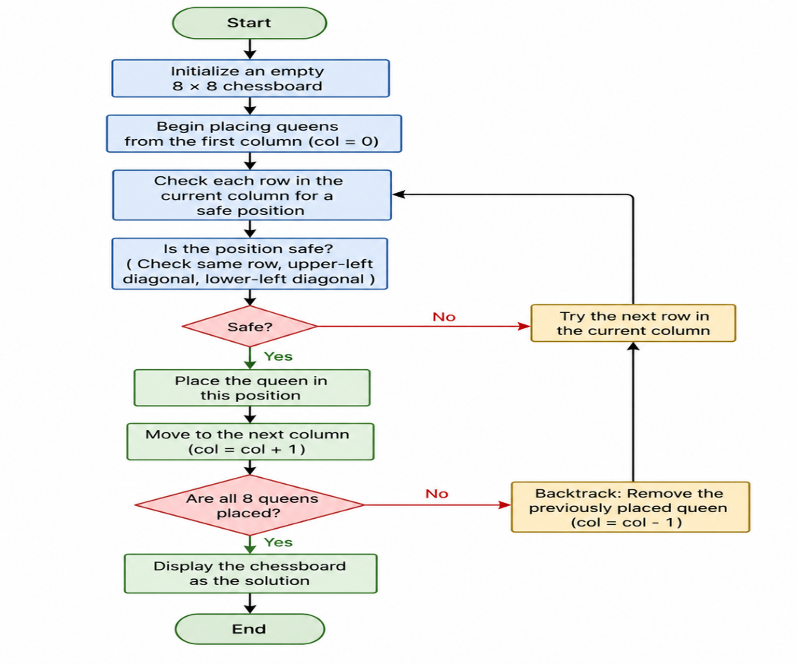
Output
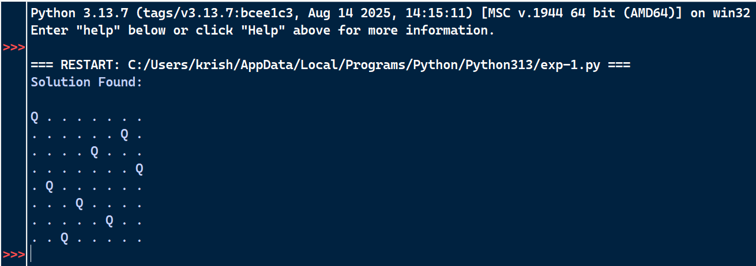
Result
Therefore the 8-Queens Problem was successfully solved using the Backtracking algorithm.

PROGRAM 2: 8-PUZZLE PROBLEM
Aim
The aim of this experiment is to solve the 8-Puzzle Problem using the Breadth First Search (BFS) algorithm
Objective
To arrange the tiles in the correct order by moving the blank space.
Algorithm
Algorithm: EightPuzzleBFS()
Step 1: Start.
Step 2: Define the initial state and the goal state of the puzzle.
Step 3: Create an empty queue.
Step 4: Insert the initial state into the queue.
Step 5: Create an empty visited set.
Step 6: Repeat until the queue becomes empty.
Remove the front state from the queue.
If the current state is already visited,
Continue with the next state.
Mark the current state as visited.
If the current state is equal to the goal state,
Display the solution path.
Stop.
Locate the blank tile (0).
Generate all valid neighboring states by moving
the blank tile Up, Down, Left or Right.
Insert every unvisited neighboring state into the queue.
Step 7: If no solution exists,
Display "No Solution Found."
Step 8: Stop.
Source Code
from collections import deque
# Initial state
initial = (
(1, 2, 3),
(4, 0, 6),
(7, 5, 8)
)
# Goal state
goal = (
(1, 2, 3),
(4, 5, 6),
(7, 8, 0)
)
def find_blank(state):
for i in range(3):
for j in range(3):
if state[i][j] == 0:
return i, j
def get_neighbors(state):
neighbors = []
x, y = find_blank(state)
directions = [(-1,0),(1,0),(0,-1),(0,1)]
for dx, dy in directions:
nx, ny = x + dx, y + dy
if 0 <= nx < 3 and 0 <= ny < 3:
new_state = [list(row) for row in state]
new_state[x][y], new_state[nx][ny] = new_state[nx][ny], new_state[x][y]
neighbors.append(tuple(tuple(row) for row in new_state))
return neighbors
def bfs(initial, goal):
queue = deque()
queue.append((initial, []))
visited = set()
while queue:
state, path = queue.popleft()
if state in visited:
continue
visited.add(state)
path = path + [state]
if state == goal:
return path
for neighbor in get_neighbors(state):
if neighbor not in visited:
queue.append((neighbor, path))
return None
solution = bfs(initial, goal)
print("Steps to solve the 8 Puzzle:\n")
step = 1
for state in solution:
print("Step", step)
for row in state:
for value in row:
if value == 0:
print("_", end=" ")
else:
print(value, end=" ")
print()
print()
step += 1
Flowchart
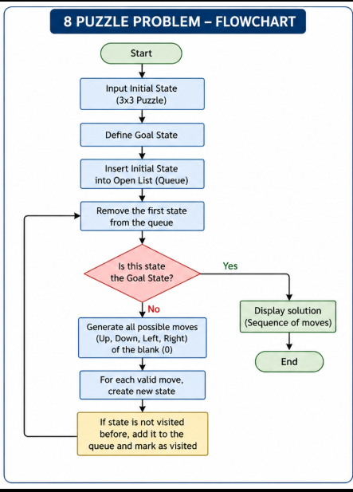
Output

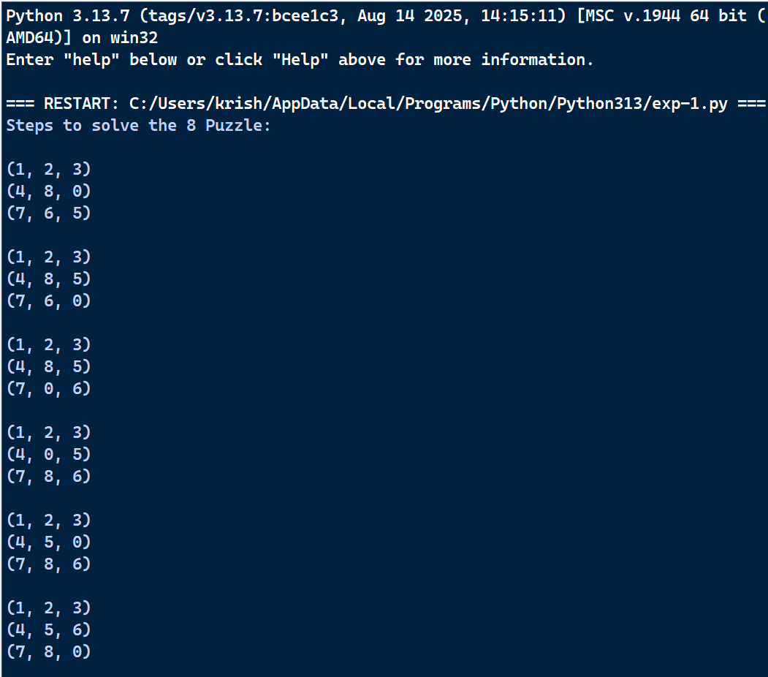
Result
Therefore, the Python program to solve the 8-Puzzle problem was executed successfully.

PROGRAM 3: VACUUM CLEANER PROBLEM
Aim
The aim of this experiment is to implement the Vacuum Cleaner Problem using a Simple Reflex Agent.

Objective
To clean all dirty rooms using a simple vacuum cleaner agent.
Algorithm
Algorithm: VacuumCleaner()
Step 1: Start.
Step 2: Initialize the environment with two rooms (A and B).
Step 3: Place the vacuum cleaner in the initial room.
Step 4: Check whether the current room is Dirty or Clean.
Step 5: If the room is Dirty,
Clean the room.
Step 6: Otherwise,
Move to the next room.
Step 7: Repeat Steps 4 to 6 until all rooms become Clean.
Step 8: Display the final status of all rooms.
Step 9: Stop.
Source Code
rooms = {
'A': 'Dirty',
'B': 'Dirty'
}
location = 'A'
while True:
print("Vacuum is in Room", location)
if rooms[location] == 'Dirty':
print("Cleaning Room", location)
rooms[location] = 'Clean'
else:
print("Room", location, "is already Clean")
if location == 'A':
location = 'B'
else:
location = 'A'
if rooms['A'] == 'Clean' and rooms['B'] == 'Clean':
break
print("\nFinal Room Status")
print(rooms)
print("\nGoal Achieved: All Rooms are Clean")
Flowchart
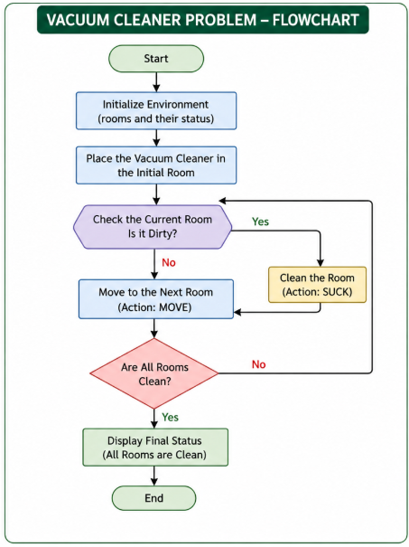

OUTPUT:
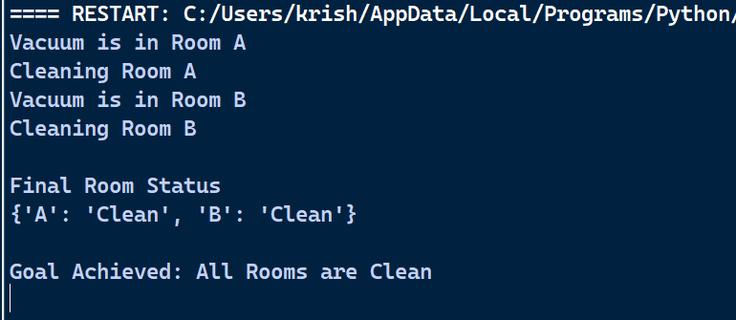
Result
Therefore, the Python program for the Vacuum Cleaner Problem was executed successfully.

PROGRAM 4: WATER JUG PROBLEM
Aim
The aim of this experiment is to solve the Water Jug Problem using the Breadth First Search (BFS) algorithm
Objective
To obtain exactly 2 litres of water using a 4-litre jug and a 3-litre jug.

Algorithm
Algorithm: WaterJugBFS()
Step 1: Start.
Step 2: Initialize the capacities of Jug1 and Jug2.
Step 3: Define the target state.
Step 4: Create an empty queue and insert the initial state (0,0).
Step 5: Create an empty visited set.
Step 6: Repeat until the queue becomes empty.
Remove the front state from the queue.
If the current state is already visited,
Continue to the next state.
Mark the current state as visited.
If the current state is equal to the target state,
Display the solution path.
Stop.
Generate all possible next states by:
Fill Jug1.
Fill Jug2.
Empty Jug1.
Empty Jug2.
Pour water from Jug1 to Jug2.
Pour water from Jug2 to Jug1.
Add all unvisited states to the queue.
Step 7: If no solution is found,
Display "No Solution Exists."
Step 8: End.
Source Code
from collections import deque
# Capacities
CAP1 = 4
CAP2 = 3
TARGET = (2, 0)
def get_next_states(x, y):
states = []
# Fill either jug
states.append((CAP1, y))
states.append((x, CAP2))
# Empty either jug
states.append((0, y))
states.append((x, 0))
# Pour Jug1 -> Jug2
transfer = min(x, CAP2 - y)
states.append((x - transfer, y + transfer))
# Pour Jug2 -> Jug1
transfer = min(y, CAP1 - x)
states.append((x + transfer, y - transfer))
return states
def bfs():
queue = deque()
queue.append(((0, 0), []))
visited = set()
while queue:
(x, y), path = queue.popleft()
if (x, y) in visited:
continue
visited.add((x, y))
path = path + [(x, y)]
if (x, y) == TARGET:
return path
for state in get_next_states(x, y):
if state not in visited:
queue.append((state, path))
return None
solution = bfs()
print("Steps:")
for step in solution:
print(step)
Flowchart
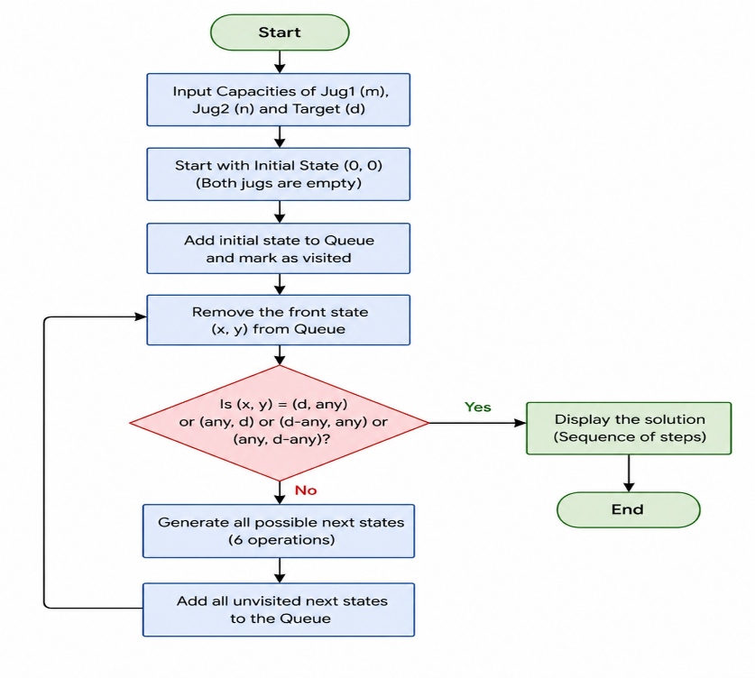
OUTPUT:
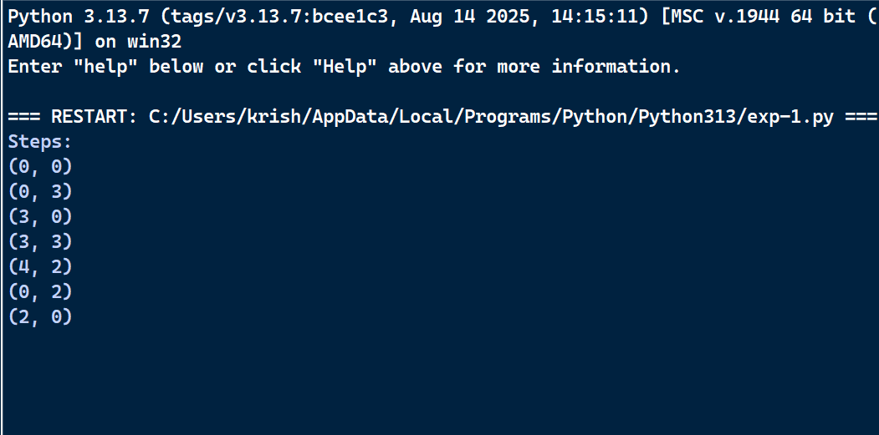
Result
Therefore, the Python program to solve the Water Jug Problem was executed successfully.

